**Lab 13: Hacking Minesweeper with Ollydbg**

**Course Name**: Malware Analysis and Reverse Engineering (IAM302)

**Student Name**: Nguyễn Trần Vinh – SE160258

**Instructor Name**: Mai Hoàng Đỉnh

**Lab Due Date**: 4/3/2023

**Purpose**

To hack MineSweeper at the binary level. This gives you practice using the Ollydbg debugger, Procdump, and Python

**What You Need**

A Windows machine, real or virtual. I used a Windows Server 2008 virtual machine

**Getting Python**

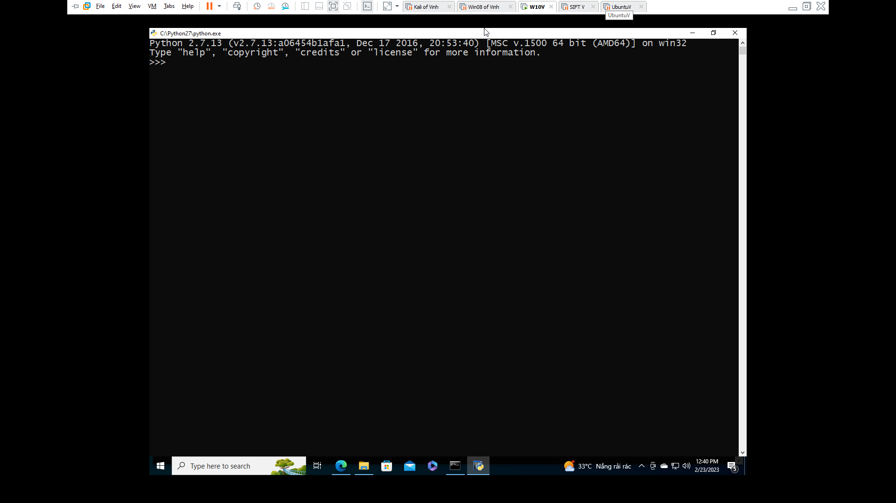

**Getting Minesweeper**

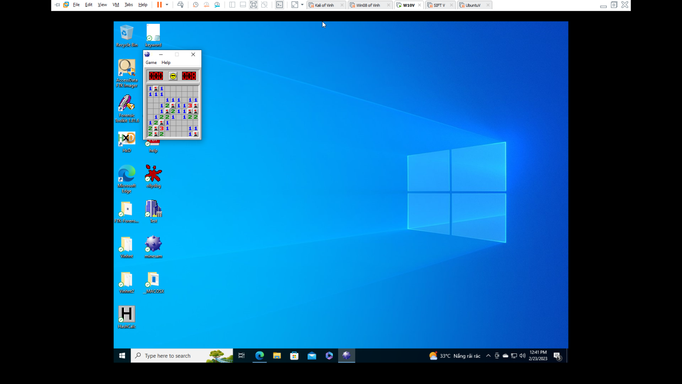

**Viewing the Game in OllyDbg**

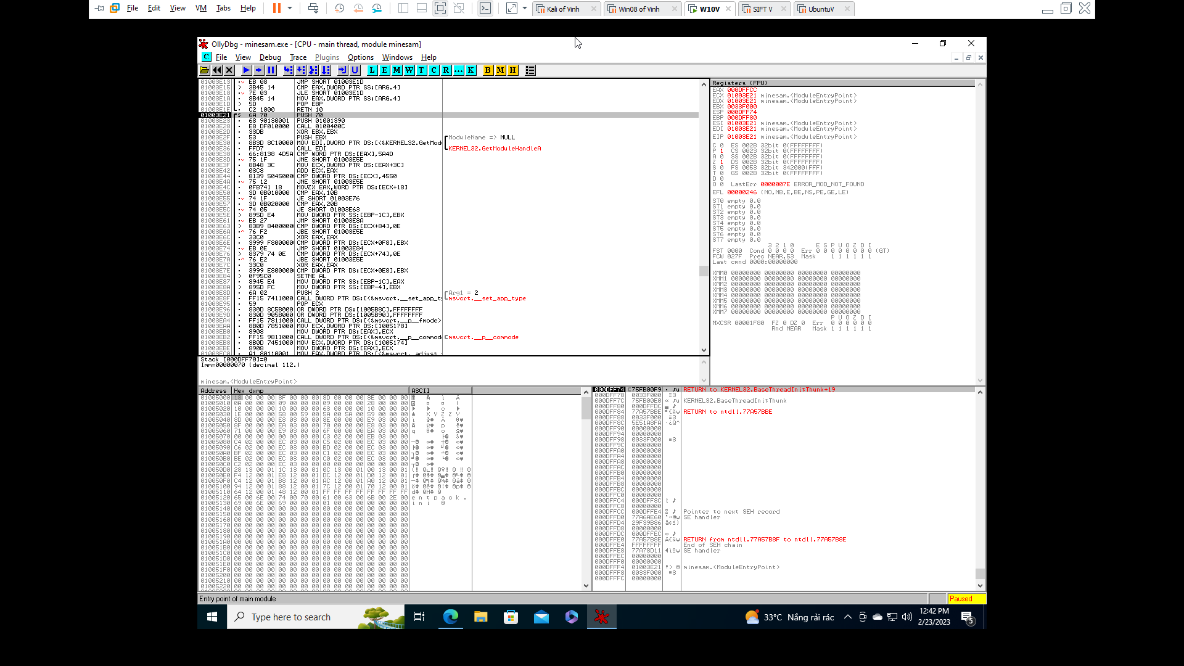 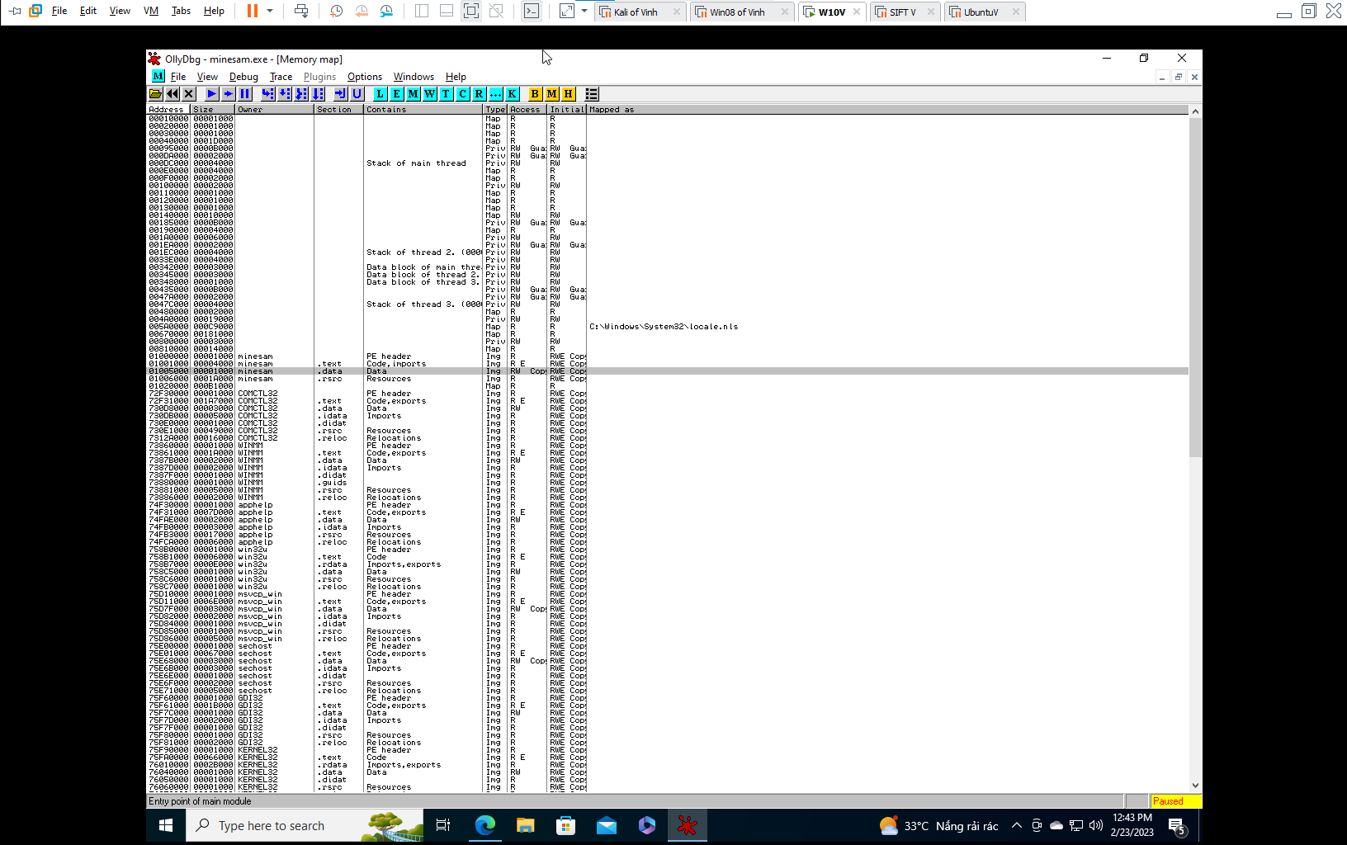

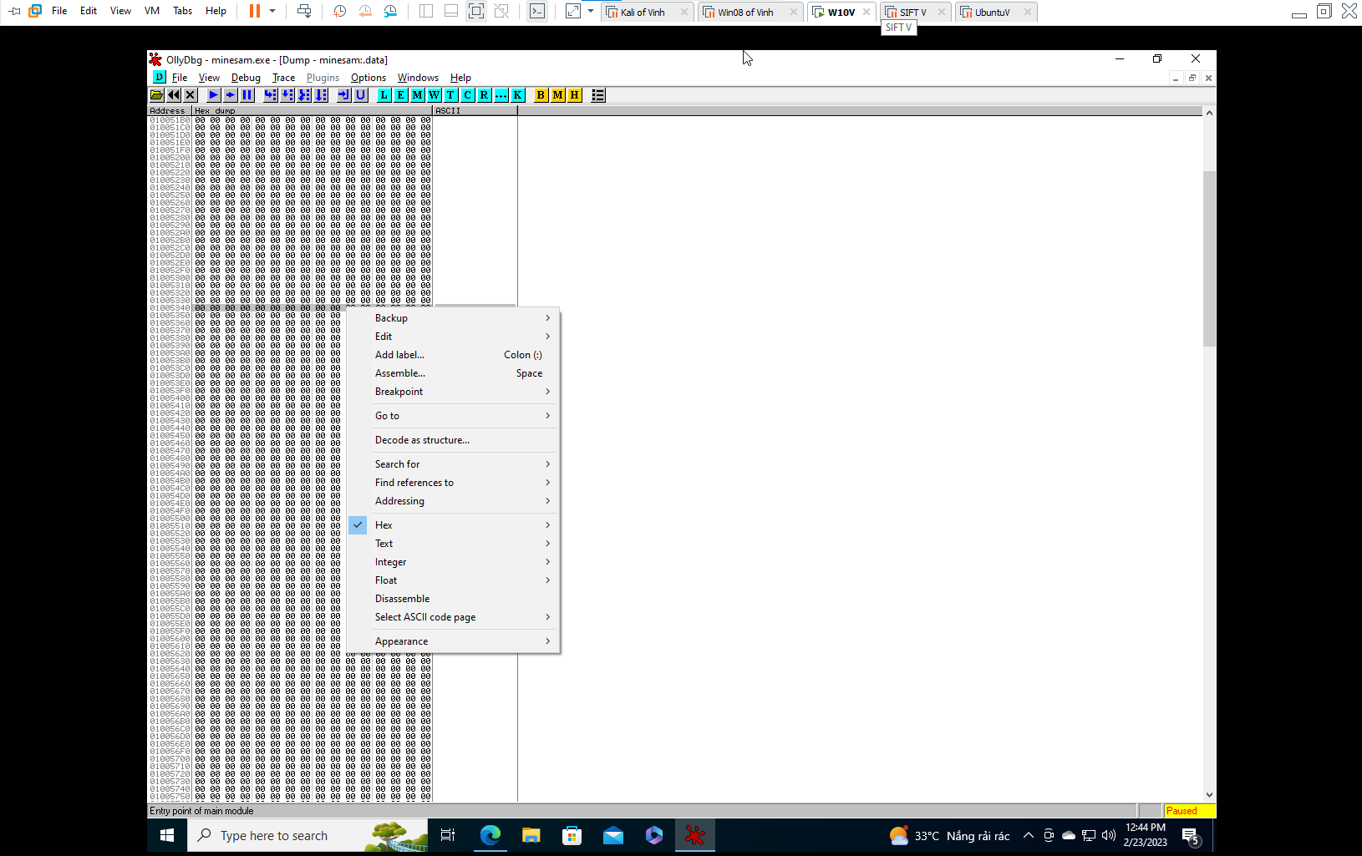 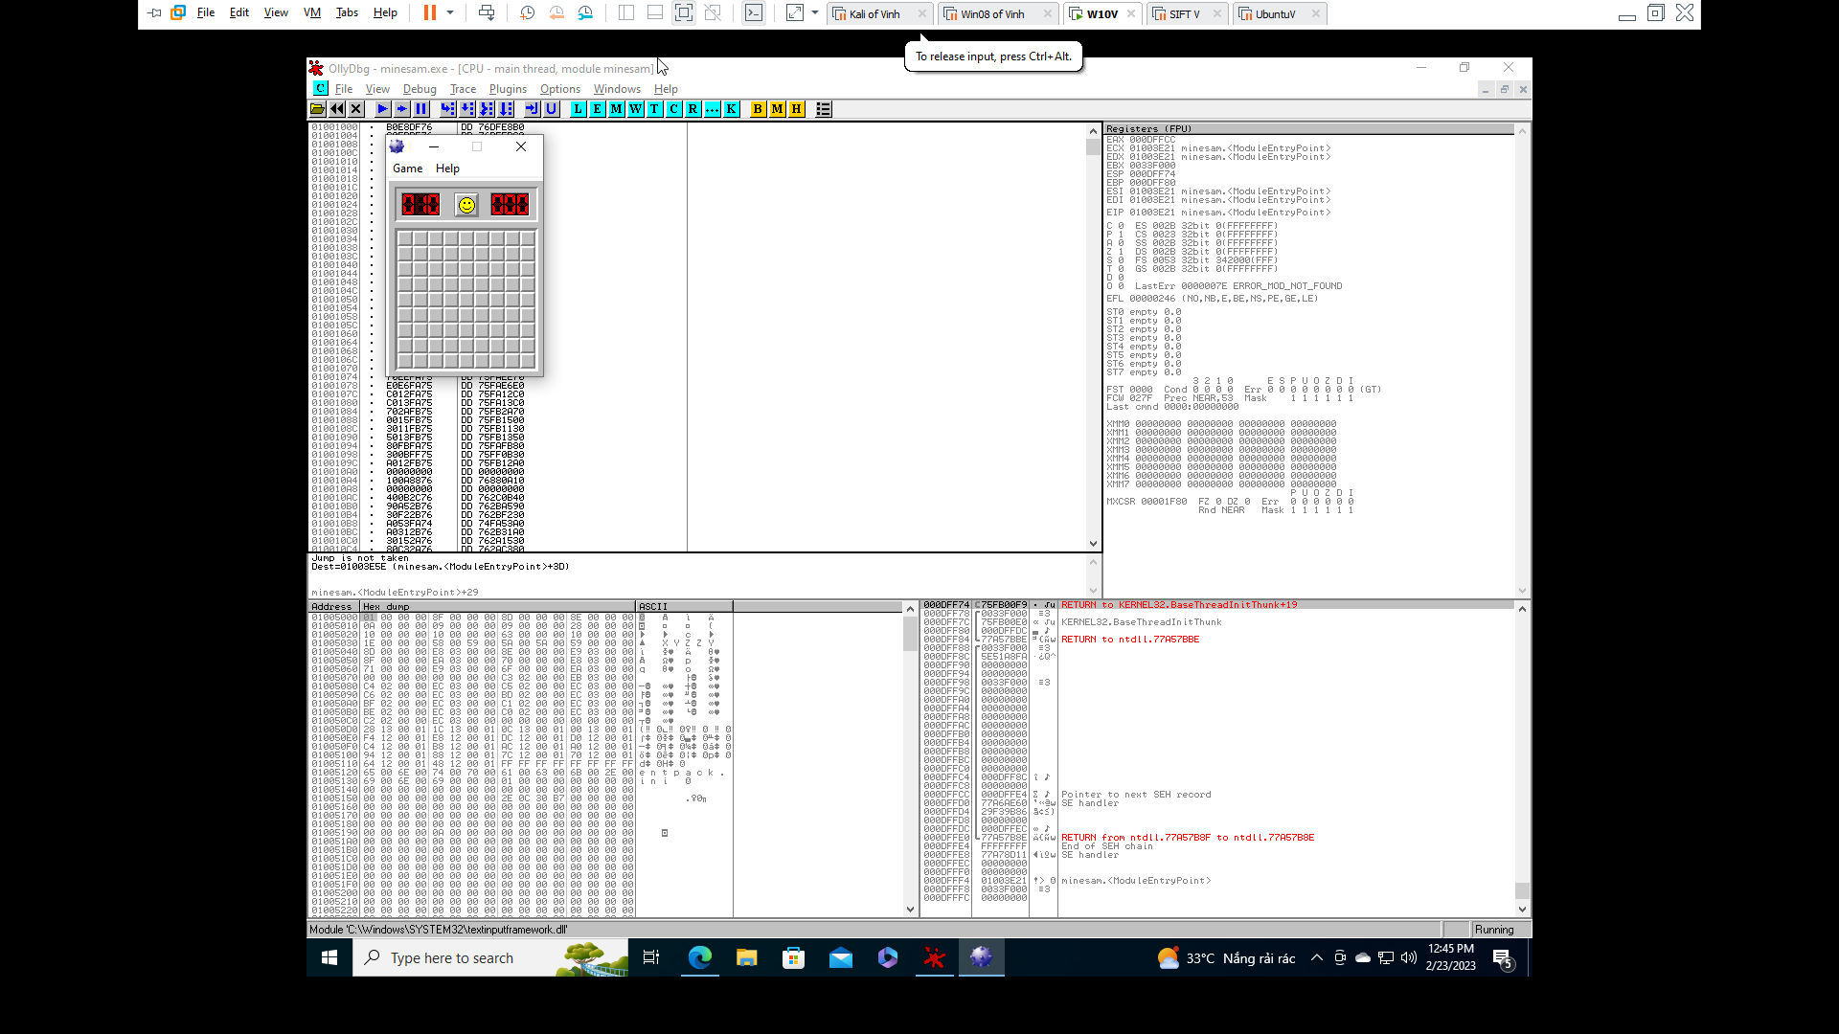 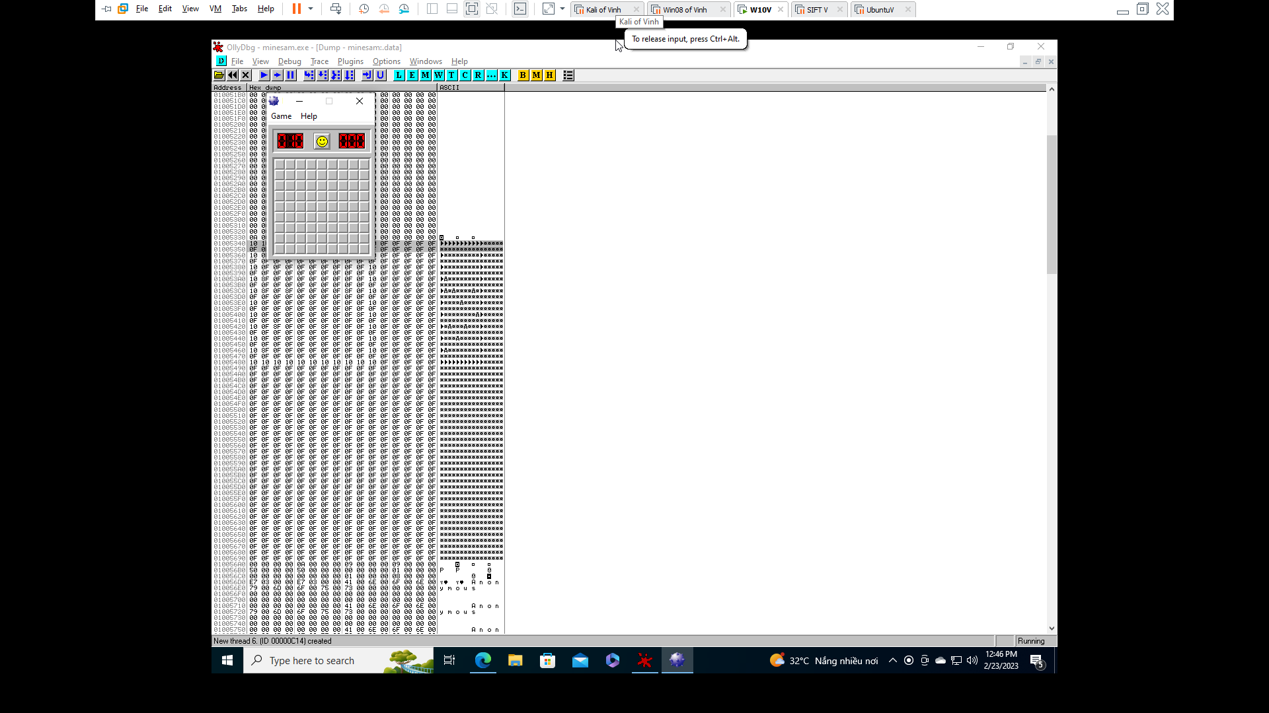 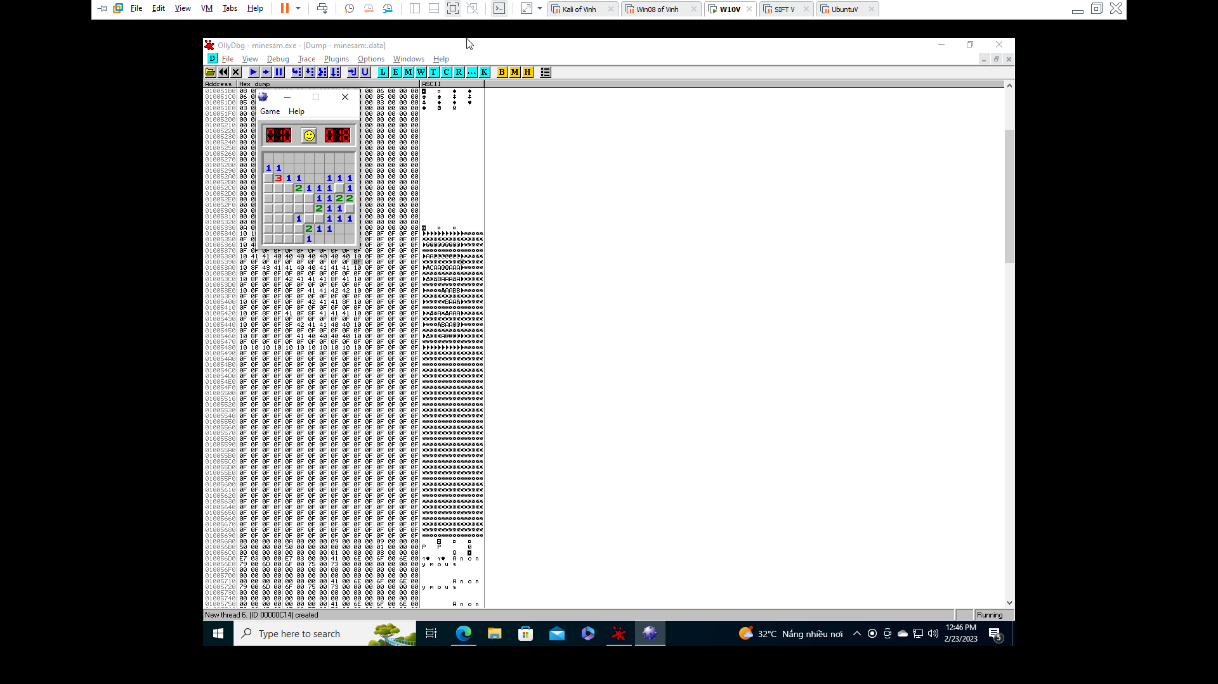

**Getting Procdump**

**Capturing Process Memory**

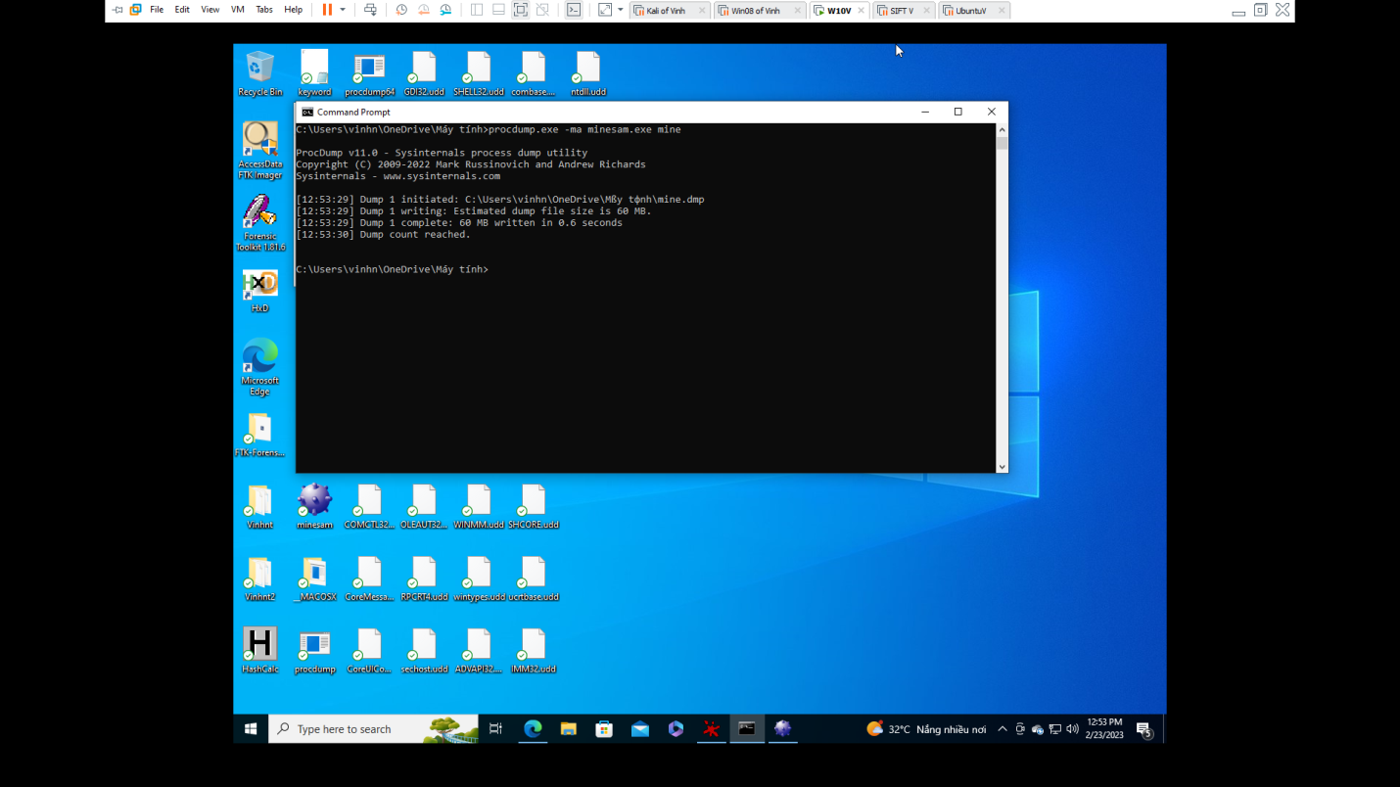

**Viewing the Memory with HxD**

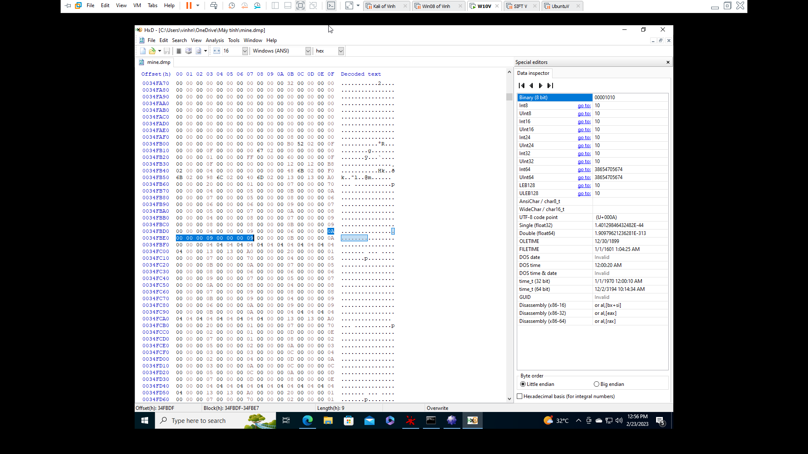

**Creating a Python Script**

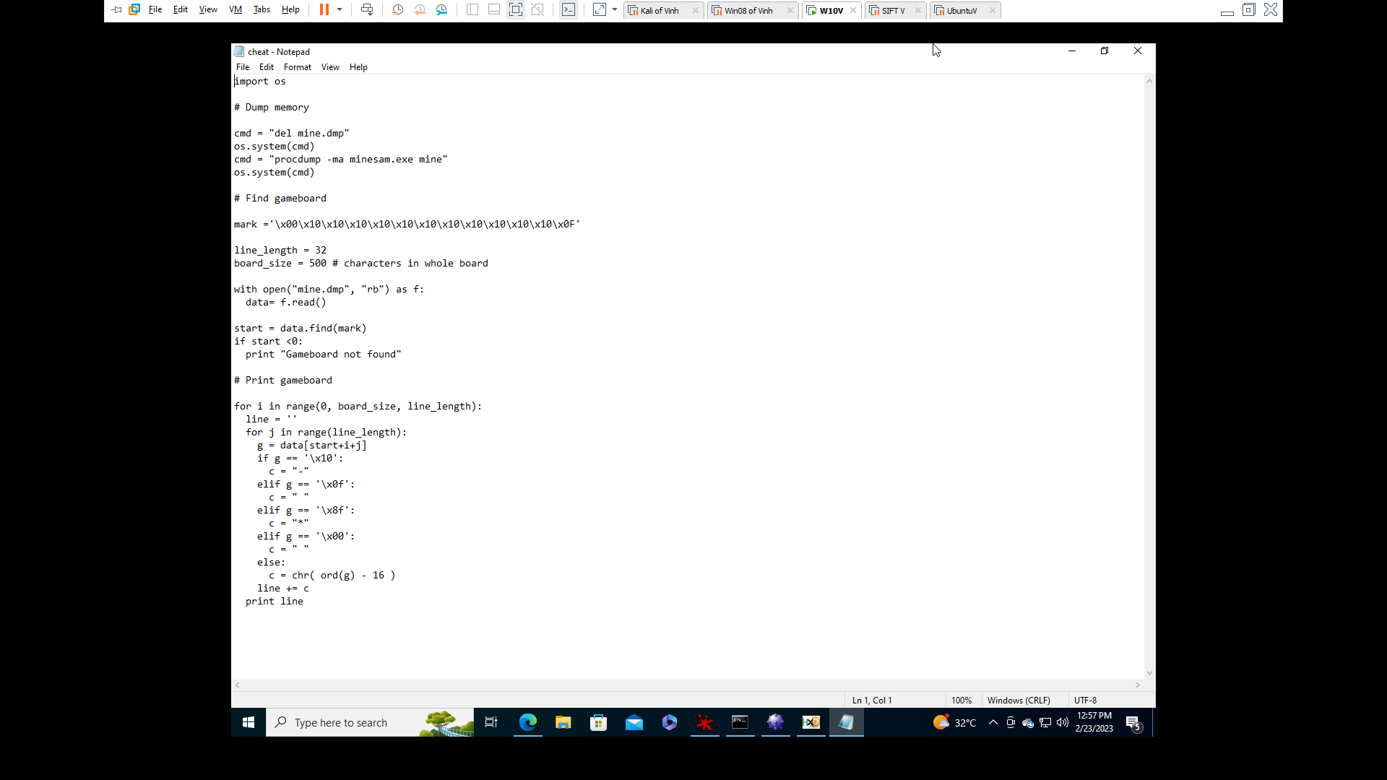 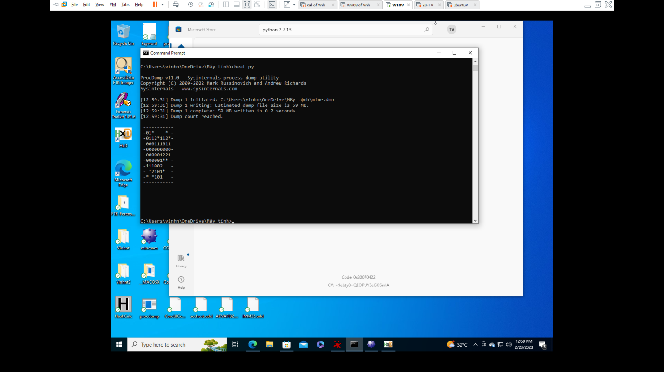 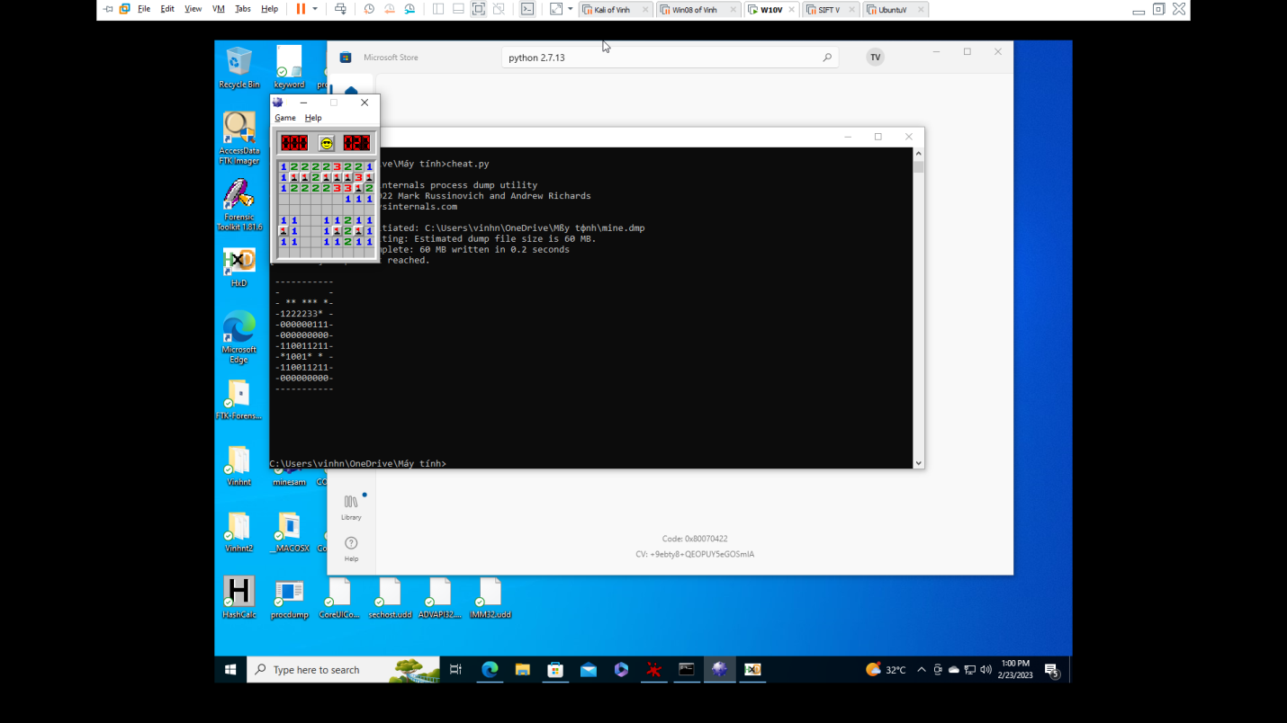

**Intermediate Level**

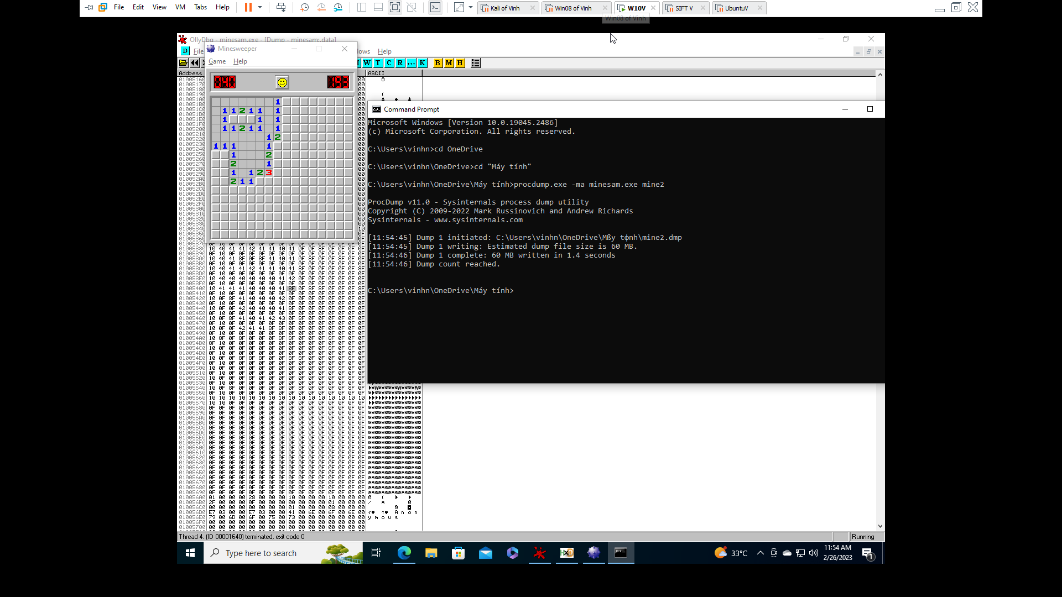 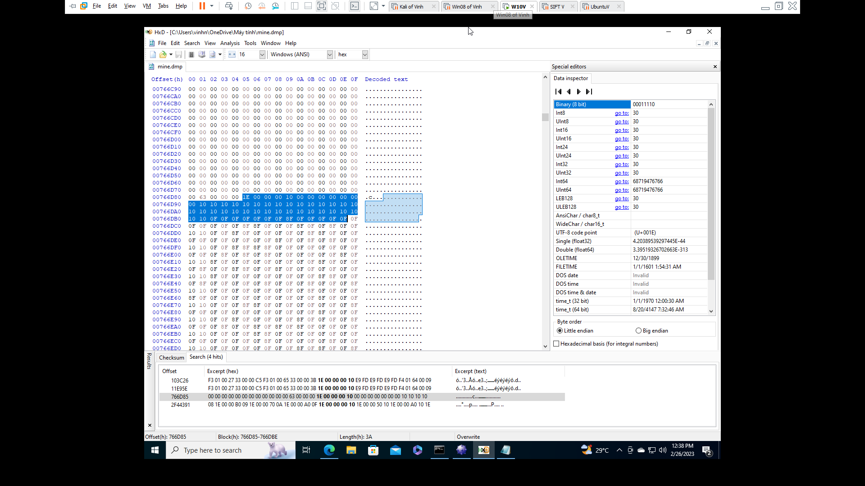 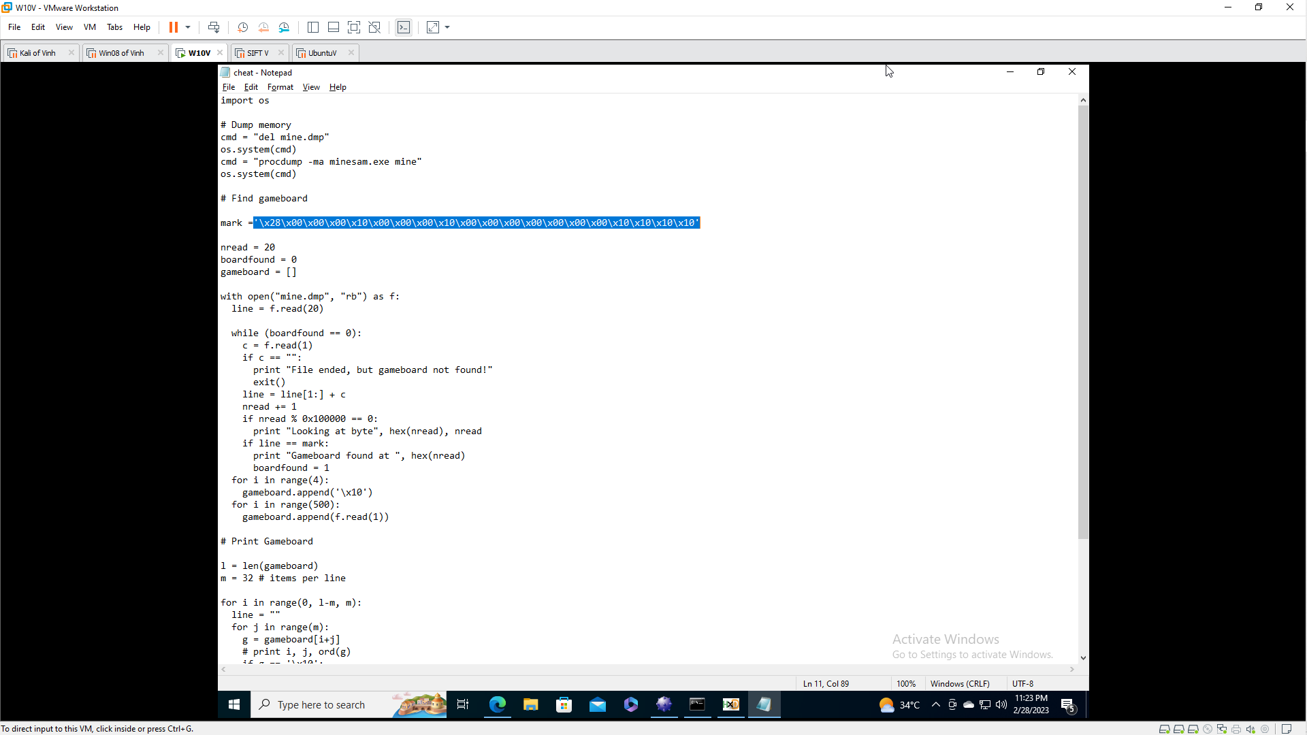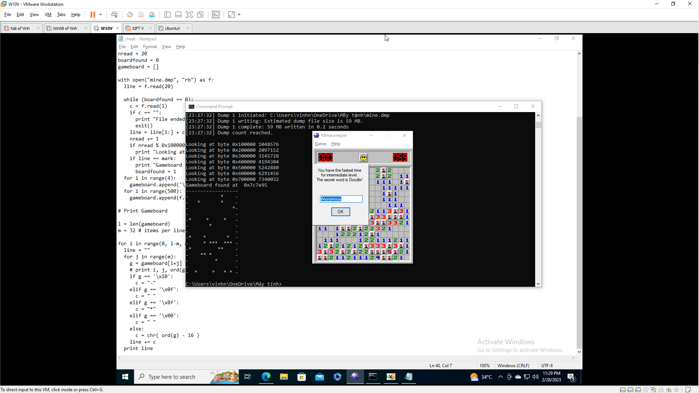

**Expert Level**

